Webpage Outline

Title (H1)

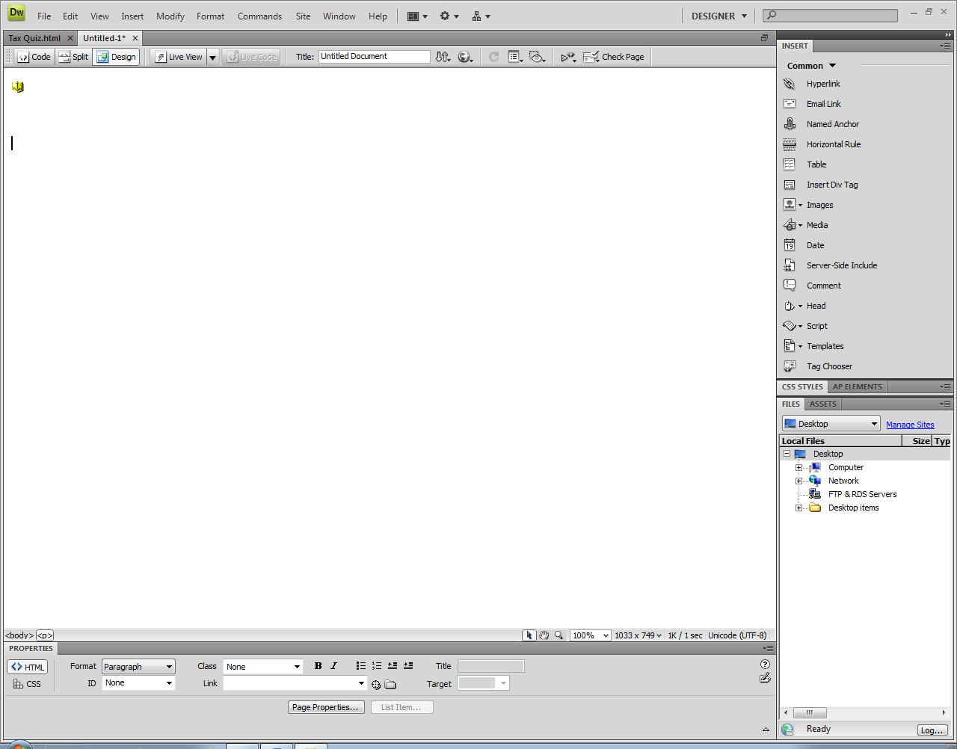

Anchor (Top)

HTML Header

How linguists and mathematicians decrypted the enigma machine using computers

Contents:   
*(Hyperlink to Heading Anchors)*

What was the enigma machine | How it worked | How it was decrypted

HTML Nav

Heading (H2)

What was the enigma machine?

HTML Article



Anchor

.......................................................................................................................................................................................................................................................................................  
Goto Top

.............................................................................................

HTML  
Section 1

Go to Top

*Hyperlink to   
Anchor*

Heading (H2)



.......................................................................................................................................................................................................................................................................................  
Goto Top

.............................................................................................

Anchor

How it worked

HTML  
Section 2



.......................................................................................................................................................................................................................................................................................  
Goto Top

.............................................................................................

Anchor

How it was decrypted

Heading (H2)

HTML  
Section 3

*Created by: Raphael Tsakrios 2022*

HTML Footer